

3.7: Defining Functions in Python (Multiplying 4 Numbers) Walkthrough

During the lecture, you were asked to produce some pseudocode for the following example:

*You need to write a program which takes in four numbers from the user, multiplies them together, and prints the answer.*

In this walkthrough, we are going to convert that pseudocode into functioning code. The following table shows how the pseudocode converts into functioning code:

| **Pseudocode** | **Functioning Code** |
| --- | --- |
| OUTPUT enter first number  INPUT number entered by user  ASSIGN to variable (num_1) | num_1 = int(input("Enter number 1: ")) |
| OUTPUT enter second number  INPUT number entered by user  ASSIGN to variable (num_2) | num_2 = int(input("Enter number 2: ")) |
| OUTPUT enter third number  INPUT number entered by user  ASSIGN to variable (num_3) | num_3 = int(input("Enter number 3: ")) |
| OUTPUT enter fourth number  INPUT number entered by user  ASSIGN to variable (num_4) | num_4 = int(input("Enter number 4: ")) |
| CALCULATE num_1 * num_2 * num_3 * num_4  ASSIGN to variable (product) | product = num_1 * num_2 * num_3 * num_4 |
| OUTPUT product | print("The product of the 4 numbers is:", product) |

Putting this together, your code should be:

def multiply_four_numbers():

num_1 = int(input("Enter number 1: "))

num_2 = int(input("Enter number 2: "))

num_3 = int(input("Enter number 3: "))

num_4 = int(input("Enter number 4: "))

product = num_1 * num_2 * num_3 * num_4

print("The product of the 4 numbers is:", product)

multiply_four_numbers()

So, your file should look as follows:

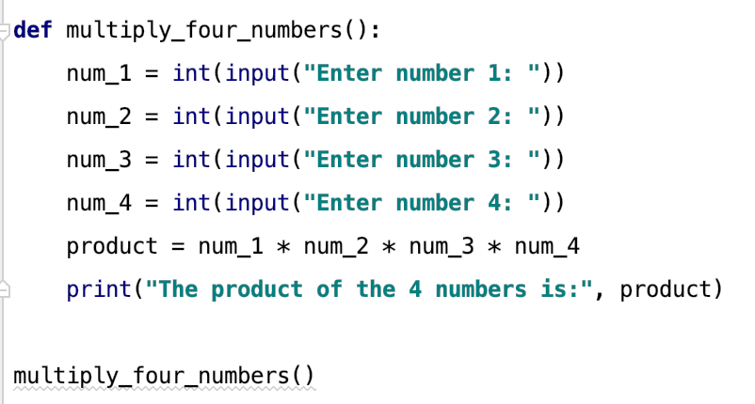

When you run the program, you get the following output:

